

**Tree Plantation 2022**

**Date of Event: 18-10-2022**

**Time: 2:40 -3:30 pm**

**Location of Event: KLH GROUND**

**Number of Persons Attending: 50**

**Faculty Coordinator:** **Dr. Mardanpally Mallesh**

**CONDUCTED BY: National Service Scheme**

Today on 18 October 2022 Tree Plantation program was held and it was successful. Many Students from both y21 and y22 participated in this event.

Not only students but many faculties manifested in this event. This shows the active participation of the KLH team. All worked jointly to make this environment green and it was victorious. About 20 plants were planted on our campus, promoting greenery and inspiring others to plant more.

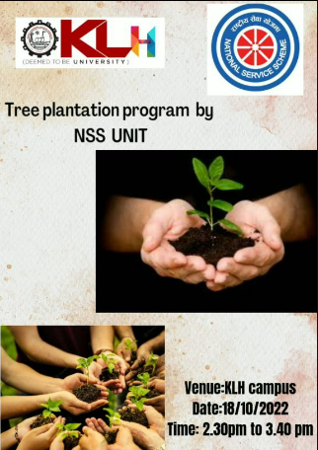

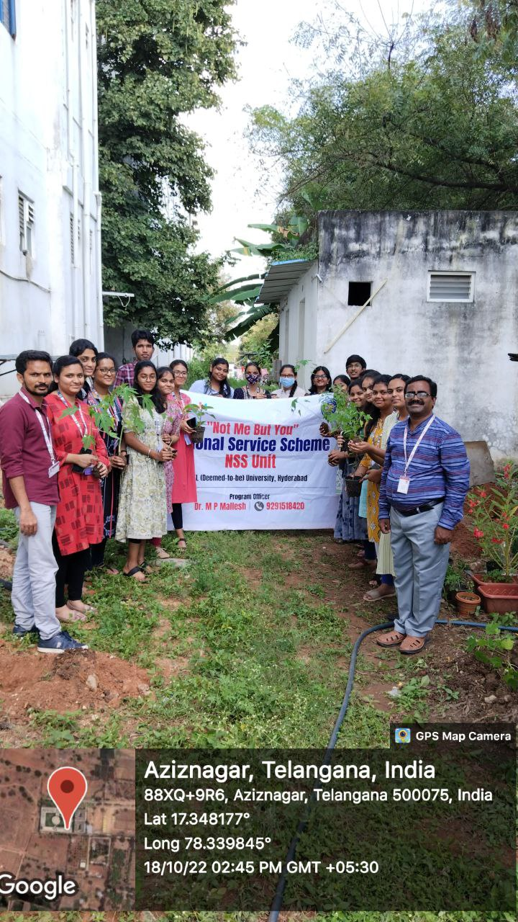 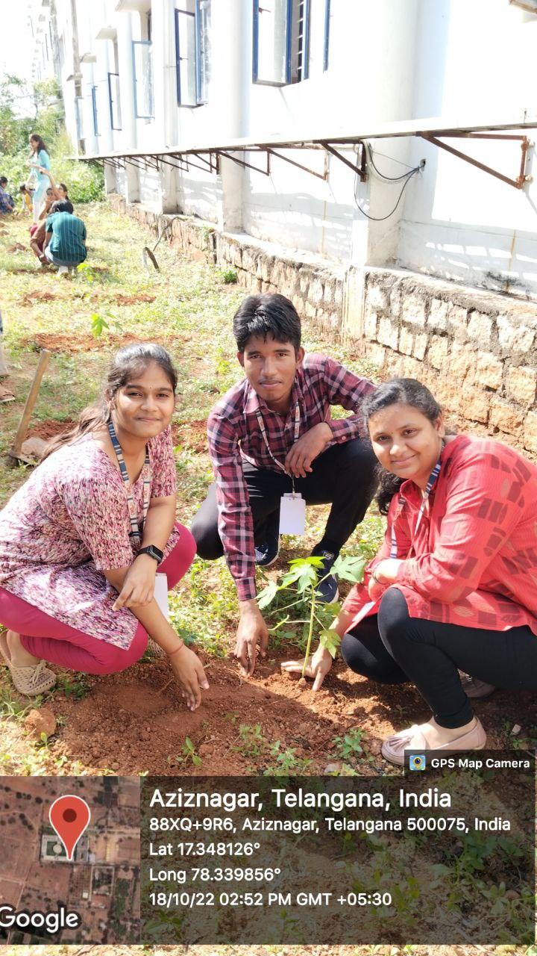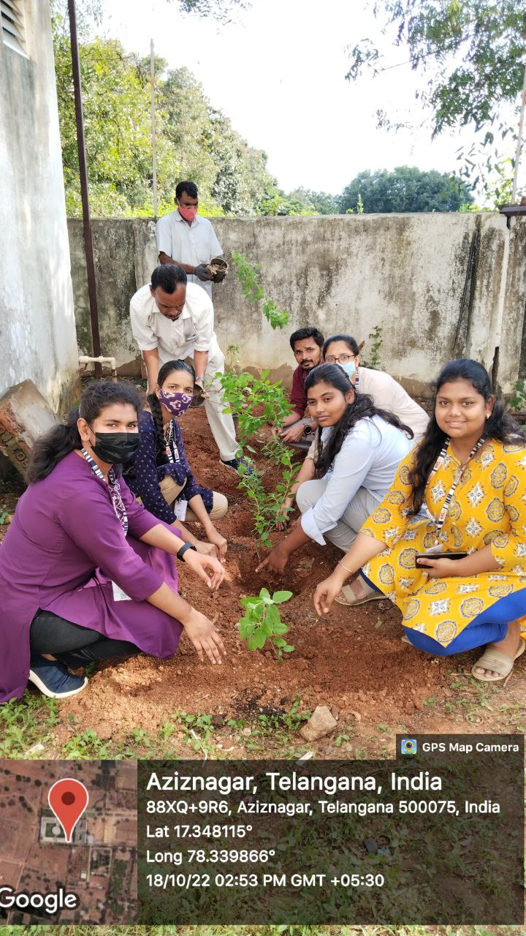

STUDENTS PARTICIPATION LIST

